**MATHPLOTLIB:**

1. **IMPORT MATHPLOTLIB:**

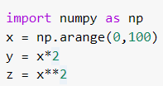

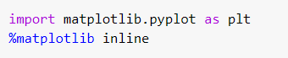

1. **Follow along with these steps:**

**Create a figure object called fig using plt.figure()**

**Use add_axes to add an axis to the figure canvas at [0,0,1,1]. Call this new axis ax.**

**Plot (x,y) on that axes and set the labels and titles to match the plot below:**

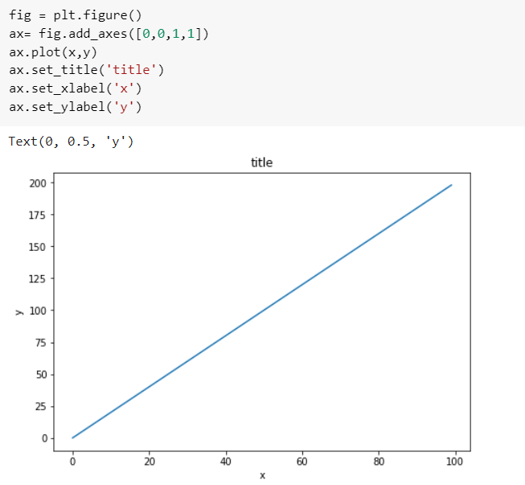

1. **Create a figure object and put two axes on it, ax1 and ax2. Located at [0,0,1,1] and [0.2,0.5,.2,.2] respectively.**

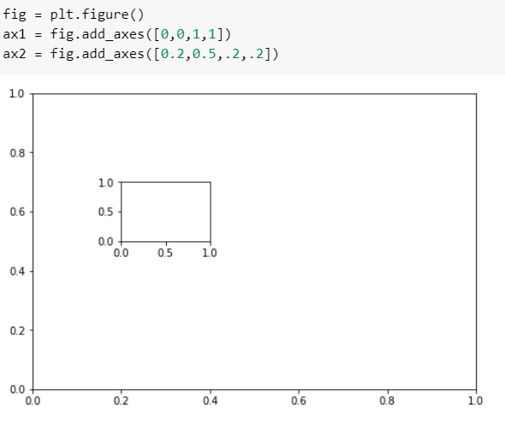

1. **Now plot (x,y) on both axes. And call your figure object to show it.**

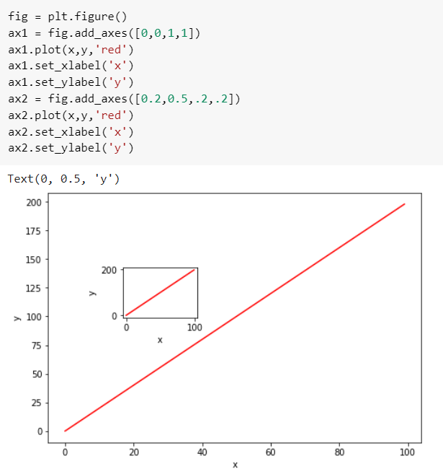

1. **Create the plot below by adding two axes to a figure object at [0,0,1,1] and [0.2,0.5,.4,.4]**

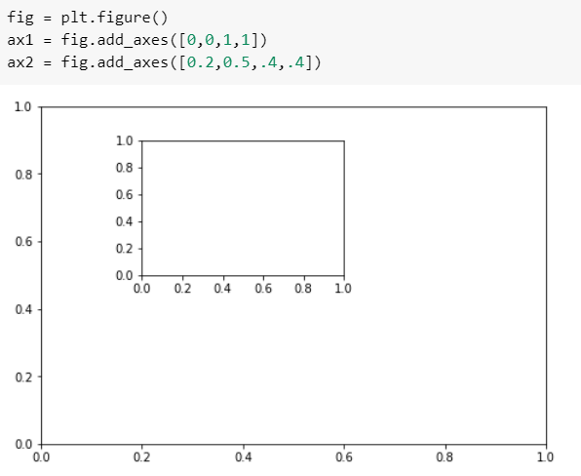

1. **Now use x,y, and z arrays to recreate the plot below. Notice the xlimits and y limits on the inserted plot:**

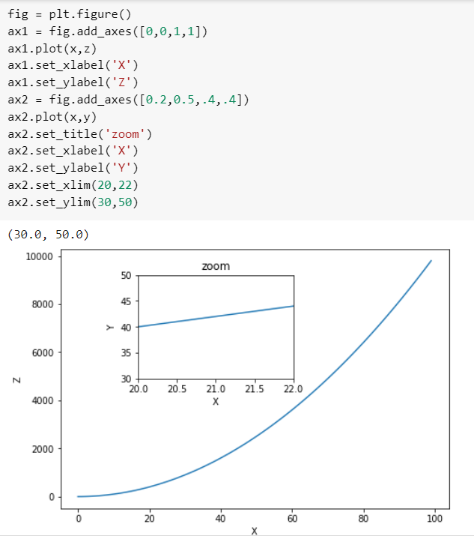

1. **Use plt.subplots(nrows=1, ncols=2) to create the plot below.**

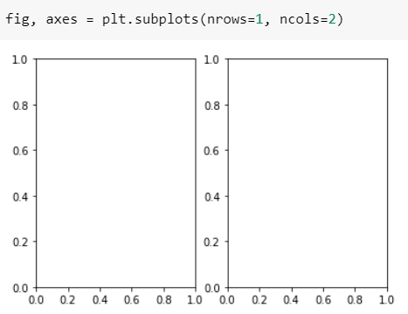

1. **Now plot (x,y) and (x,z) on the axes. Play around with the linewidth and style**

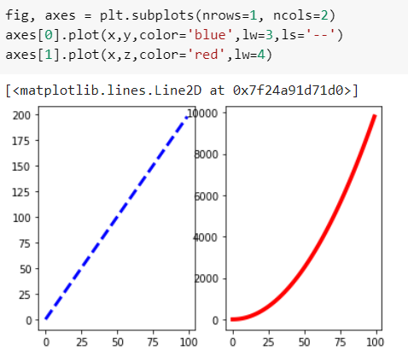

1. **See if you can resize the plot by adding the figsize() argument in plt.subplots() are copying and pasting your previous code.**

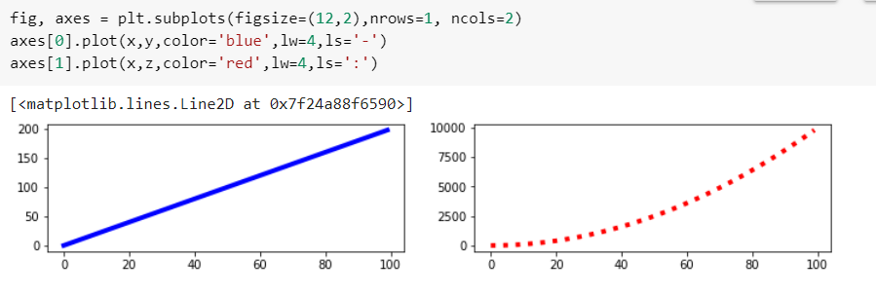

#### CONCLUSION:

#### From this practical, I have successfully learned about mathplotlib library in python.